

quality report

Qafox Web Application



September 2024

Table of Contents

Quality Status 2

Test Environments Covered 2

List of Existing Defects 2

# Quality Status

The quality of the TutorialsNinja Application Version 13.56 is better than the previous versions. In this version, the important issues still exits and hence we ‘**Not Recommend this version for Release**’.

# Test Environments Covered

We have tested TutorialsNinja Web Application Version 13.56 in all the below different Test Environments:

* Windows 10 – Chrome, Firefox, IE 11 and Edge
* Mac OS – Safari Browser
* Linux Ubuntu OS – Firefox
* Android Mobile OS – Chrome
* iPhone Mobile OS – Safari

# Defects by Functional Area

The below is the count of existing defects by Functional Area:

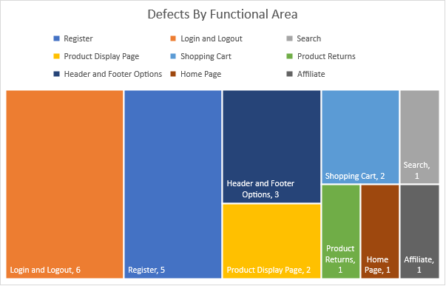

# List of Existing Defects

The below are the list of existing defects which are still existing in the TutorialsNinja Web Application Version 13.56:

|  |  |  |
| --- | --- | --- |
| **Defect#** | **Description** | **Severity** |
| TU1-I2 | Thank you for registering' email is not received to the registered email address after registering an account | Minor |
| TU1-I4 | 'Privacy Policy' Checkbox field in 'Register Account' page is not marked with red colour * symbol | Minor |
| TU1-I5 | 'Telephone' field in 'Register Account' page is accepting the spaces and not showing warning message | Minor |
| TU1-I6 | 'Password' and 'Password Confirm' fields in 'Register Account' page are accepting simple passwords | Major |
| TU1-I7 | Leading and Trailing spaces are accepted by the text fields in the 'Register Account' page | Minor |
| TU1-I8 | User is getting logged out on clicking Browser back button | Critical |
| TU1-I9 | User is getting logged in automatically on browsing back immediately after logout | Major |
| TU1-I10 | User is getting logged in automatically on browsing back immediately after logout | Major |
| TU1-I11 | User is not automatically getting logged out of the Application after 30 minutes of inactivity | Minor |
| TU1-I12 | User is not getting logged out in one browser, when logged out in another browser | Minor |
| TU1-I13 | Email address is not getting carry forwarded from the 'Login' page to 'Forgot Your Password' page | Minor |
| TU1-I14 | Using tab keyboard key is not highlighting the 'Search in subcategories' checkbox field | Minor |
| TU1-I15 | Negative, Null and Zero values are accepted by the Qty field in Product Display Pages | Minor |
| TU1-I16 | Warning message informing the User to provide positive quantity is not getting displayed on updating the quantity with negative, zero or blank in the 'Shopping Cart' page | Minor |
| TU1-I17 | $8 is displayed instead of $5 in the displayed 'Estimate Shipping & Taxes' dialog | Major |
| TU1-I18 | User can provide future date for the 'Order Date' field while returning the order | Major |
| TU1-I19 | Page text is not displayed in the 'About Us', 'Delivery Information', 'Privacy Policy’ and 'Terms & Conditions' page | Minor |
| TU1-I20 | Normal User who has not registered for the Affiliate account is able to login from 'Affiliate Login' section | Minor |
| TU1-I21 | Options are not displayed in the 'Select' dropdown list of 'Canon EOS 5D' product display page | Major |
| TU1-I22 | Logo of the Application is missing, instead 'Your Text' is getting displayed | Minor |
| TU1-I23 | Clicking on the first Hero image is taking us to a wrong Product Display Page | Minor |
| TU1-I24 | A blank 'Contact Us' page is displayed on submitting the form in 'Contact Us' page | Minor |